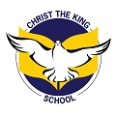
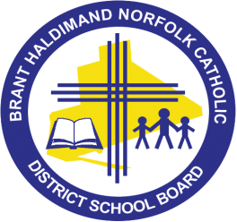
CHRIST THE KING SCHOOL
165 Dufferin Avenue, Brantford, ON N3T 4R4
Telephone (519)759-4211

Dear Parents & Guardians, 12/12/18
We are very excited about our upcoming Family Christmas Social that will be held on Tuesday December 18th from 5:30- 7:30 pm.
Most of our classes will participate in leading two Christmas Carol sing-alongs! We are asking our parents to ensure that their child(ren) are in the gym at the appropriate class scheduled time(s) if your child(ren) would like to participate in this part of the festive family event (it is optional). Please see the caroling schedule for your planning convenience.
Sing-along Schedule in Gym:
5:30- Social begins
5:45- Grade 2s (Ms. Freund & Mrs. Ramey)
5:55- Kindergarten 2s (Mrs. DoCouto & Mrs. Lisk)
6:05- Grade 3/4 & 5/6s (Mrs. Ribeiro, Ms. Sant & Mr. Hughes & Ms. Bennett)
6:15- Grade 3s (Mrs. Maddan & Ms. Levac)
6:30- Kindergarten 1s (Mrs. Hartt & Ms. Roy)
6:40- Grade 1s (Ms. Rudy & Ms. Moyer)
6:50- School Choir sings along (Mrs. Hartt)
7:10- Parent Council Basket raffle draws!!!
Special Planned Events:
ELKP 1 class will host a variety of Christmas making crafts
ELKP 2 class will host SANTA and an opportunity for family photos!!!
The gym will host Christmas carols, hot chocolate, cookies & class basket raffle
Our library- Family soup making jars & Grade 7/8 Christmas music video presentations

We are looking forward to having a jolly good ol’ time! Wishing everyone a blessed Family Social. Hope to see everyone sharing in the Christmas spirit.

With Warm Regards,
Mrs. Hanley

NEWS FLASH
GET YOUR CHRISTMAS SPIRIT ON AT CTK!!

We have decided (as a last-minute opportunity to spread Christmas cheer) to plan daily themed days for the last week of school. HO HO HO!
Please see the schedule below:
(Students are welcome to participate in as many as they wish~ there is no pressure to participate)

MONDAY Dec. 17- Christmas PJ & Slippers day
TUESDAY Dec 18- UGLY sweater day
WEDNESDAY Dec 19- Christmas hat wear day
THURSDAY Dec 20- Christmas theme/character day (Santa, elf, reindeer, Christmas tree, presents, wisemen etc.)
FRIDAY Dec 21- Red & Green day

