“THE STAR”- A Tale of Faith & Friendship
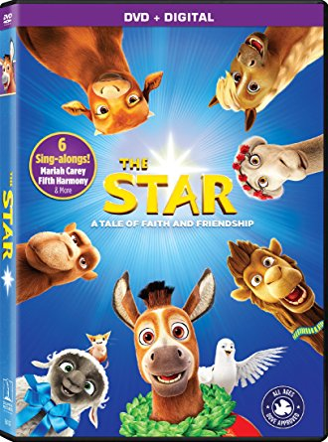
ON: Tuesday November 27th, 2018 at Christ the King’s gym!
Doors open at 5:00pm/ Movie begins at 5:30pm
So come in your PJs or comfy clothes, and bring your pillows, lawn chairs and blankets.
To help us serve you best…please place your food orders in advance.
We look forward to sharing a good ol’ family time with you!
Return Portion Below>>>>>>>>>>>>>>>>>>>>>>>>>>>>>>>>>>>>>>>>>>>>>>>>>>>>>>>>>>>>>>>>>>>>>>>>-
Pre-Order Family Movie Night Food Form- November 26th
Family Name: _________________________________________ will be attending.
# Popcorn ______ X $2.00 = ___________ # Slices of pizza______ X $1.00 = ________
# Veggies & dip ______ X $1.00= ________ # Licorice sticks ______ x .25 cents=________
# Juice boxes ______ x $1.00=________ # Waters ___________ x $1.00=_________
Total cost= _______________________ We will not collect any money early- Pls pay the night of movie

